PENDLETON COUNTY SCHOOLS
June 1, June 8 & June 15, 2020- SFSP Menu
“MENUS ARE SUBJECT TO CHANGE BASED ON FOOD AVAILABILITY and COVID-19 Factors”

Week 1:
Cinnamon Toast Crunch Cereal Bar
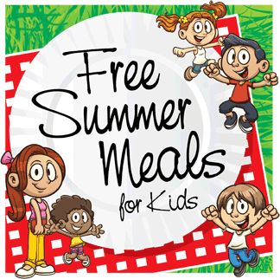
Grape Juice
Milk
PB & Jelly Uncrustables
Cheese Stick
Juice
Milk

Week 2:
Assorted Grains: Bagel, Muffin
Fruit Cup
Juice Box
Milk
Campbell’s Soup/Cheese Stick
Yogurt
Goldfish Crackers
Fruit Cup
Juice Box
Milk

Week 3:
Cereal Bowl Packs
Juice Box
Fresh Fruit
Milk
Julia’s Pepperoni Roll- Chico’s Bakery, Morgantown, WV
Cheese stick
Fresh Fruit
Milk

Feeding Sites: North Fork Elementary, Brandywine Elementary, Pendleton County Middle High School
Feeding Time: 10:00AM-12:00PM, Monday’s ONLY

