North Fork  Elementary School  2021 |  |  |  |  | 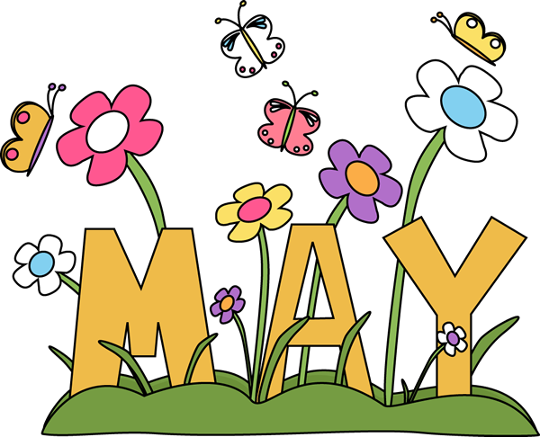
Sunday | Monday |  | Tuesday | Wednesday |  | Thursday | Friday | Saturday
 |  |  |  |  |  |  |  | 1
2 | 3 |  | 4 | 5 |  | 6 | 7 | 8
 | State Testing  Grade 4  Math |  | State Testing  Grade 4  ELA | State Testing  Grade 4  Writing
9 | 10 |  | 11 | 12 |  | 13 | 14 | 15
 | State Testing  Grade 3  Math |  | State Testing  Grade 3  ELA | State Testing  Grade 3  Writing
16 | 17 |  | 18 | 19 |  | 20 | 21 | 22
Make-up Testing
this week
23 | 24 |  | 25 | 26 |  | 27 | 28 | 29
30 |  | 31 | 1 June | 2 |  | 3  6th | 4 | 5
 |  | No School  Memorial Day |  | Last day for Preschool |  | 6th Grade Orientation, PCMS  Last day for Kindergarten | Early Release  Last day for students

