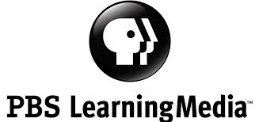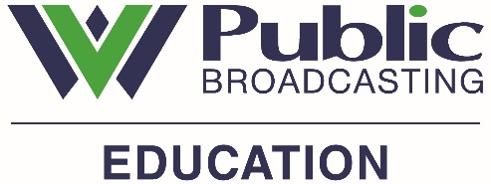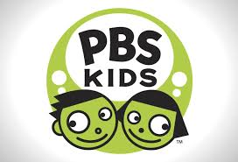

PBS LearningMedia is a FREE digital media library that provides direct access to thousands of classroom-ready, curriculum-targeted resources for PreK-12 educators and students in all content areas. It features digital resources from more than 90 educational producers and station partners and includes:
- Thousands of digital resources mapped to National and State Standards;
- Teacher-friendly user experience allowing educators and students to filter and find relevant, high-quality instructional resources;
- Save and share functionality enabling educators to collaborate; and
- Quality tools to allow educators and students to create their own lessons, puzzles, quizzes, and storyboards.
GO TO: http://www.wv.pbslearningmedia.org OR https://www.wv.pbslearningmedia.org
Look near the top right hand corner of the page to find the sign-in information.
If you are new to PBSLearningMedia you will be asked to create an account.
- When you register use a WV zip code. Your role should be K-12 post-secondary educator. Please include your school and county name. WVPB and PBS DO NOT give your contact information to anyone!
- Once you are registered your first name will appear in the top right hand area each time you sign in.
WHEN YOU SEARCH!
- You may limit your search by grade level, subject and media type.
- Mark the “heart” symbol to the left of the resources you like and want to use later. They will be saved in your “favorites” folder under the Dashboard.
- You will find the Dashboard by clicking on your name in the top right hand corner.
- Become familiar with the Tools under the Dashboard – puzzle builder, quiz maker, storyboard, and lesson builder.
- Register your students and their family members.

