 | PENDLETON COUNTY SCHOOLS
SFSP Menu
“MENUS ARE SUBJECT TO CHANGE BASED ON FOOD AVAILABILITY and COVID-19 Factors”

 | Week 1: (June 1)  Cinnamon Toast Crunch Cereal Bar  Grape Juice  Milk  PB & Jelly Uncrustables/Cheese Stick  Juice  Milk | Week 4: (June 22)  Cereal Bars  Juice Box  Milk  Hot Off the Grill Sandwich/Cheese stick  Juice Box  Applesauce Cup  Fresh Vegetable  Milk
 | Week 2: (June 8)  Assorted Grains: Bagel, Muffin  Fruit Cup  Juice Box  Milk  Campbell’s Soup/Cheese Stick/Yogurt  Goldfish Crackers  Fruit Cup  Juice Box  Milk | Feeding Sites: North Fork Elementary, Brandywine Elementary, Pendleton County Middle High School  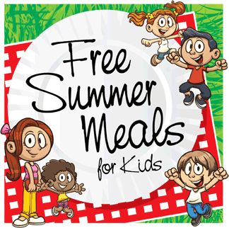  Feeding Time: 10:00AM-12:00PM, Monday’s ONLY
Week 3: (June 15)
Cereal Bowl Packs
Juice Box
Fresh Fruit
Milk
Julia’s Pepperoni Roll- Chico’s Bakery, Morgantown, WV
Cheese stick
Fresh Fruit
Milk

